Algebra — Objective 4-1
Identifying Linear Functions
Name: ______________________________ Date: ______________
Part 1 — Identify from a Graph
Circle Linear or Not Linear. Then explain how you know.
1. 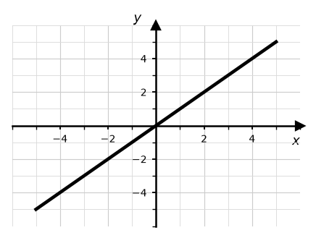  Linear / Not Linear  How do you know? ____________________ | 2. 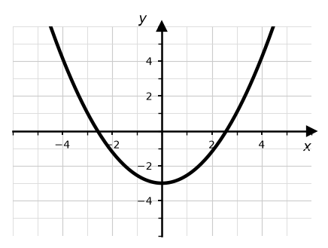  Linear / Not Linear  How do you know? ____________________
3. 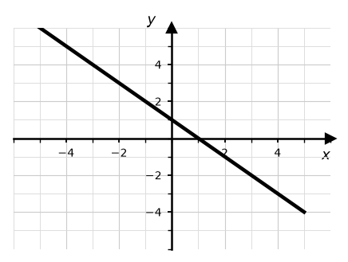  Linear / Not Linear  How do you know? ____________________ | 4. 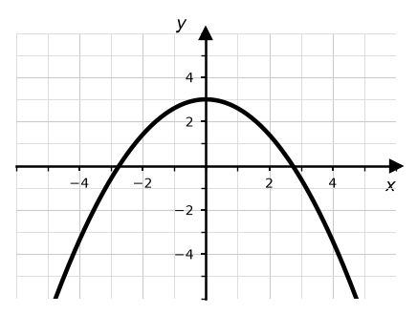  Linear / Not Linear  How do you know? ____________________
Part 2 — Identify from an X-Y Table
Circle Linear or Not Linear. Then explain how you know.
5.  Linear / Not Linear  How do you know? ____________________ | 6.  Linear / Not Linear  How do you know? ____________________
  x | y
  -2 | -5
  -1 | -2
  0 | 1
  1 | 4
  x | y
  -2 | 4
  -1 | 1
  0 | 0
  1 | 1
7.  Linear / Not Linear  How do you know? ____________________ | 8.  Linear / Not Linear  How do you know? ____________________
  x | y
  0 | 7
  1 | 5
  2 | 3
  3 | 1
  x | y
  1 | 1
  2 | 4
  3 | 9
  4 | 16

Part 3 — Find Y and Graph
Fill in the y-values, plot the points on the grid, then circle Linear or Not Linear.
9. y = 2x + 1  Linear / Not Linear | 10. y = x²  Linear / Not Linear
   | 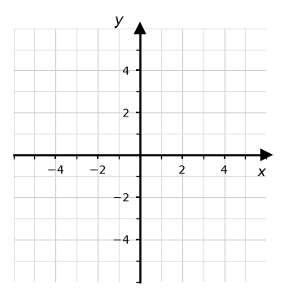
    x | y
    -2
    -1
    0
    1
    2
  x | y
  -2
  -1
  0
  1
  2
11. y = -x + 2  Linear / Not Linear | 12. y = x² - 3  Linear / Not Linear
  x | y
  -2
  -1
  0
  1
  2
  x | y
  -2
  -1
  0
  1
  2

